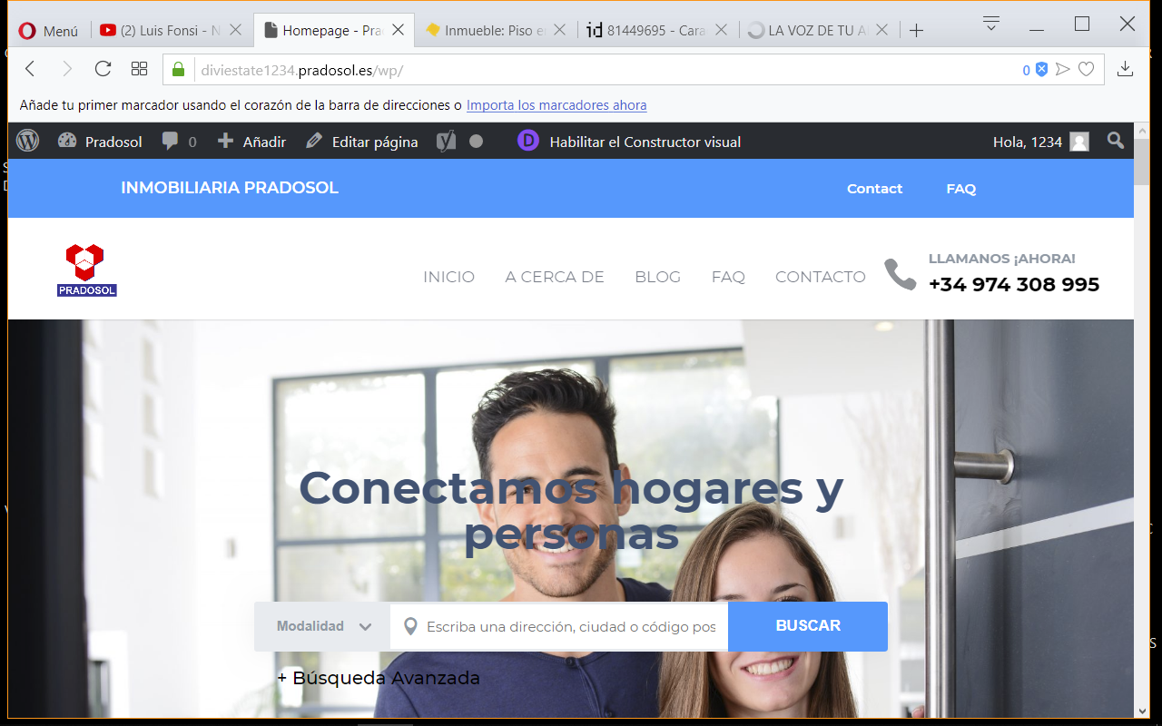

I want to delete the "contact" and "Faq" sections in the header bar

How can I do it?

